SAAD Module 01 – Class & Sequence Diagrams – Kai Sawler – Jan 11th, 2018

1)

public class Shape_01 {

int direction_x = 0;
int direction_y = 0;
int turn_x = 0;
int turn_y = 0;

public void move_x_forward() {
turn_x = 1;
}

public void move_x_backward() {
turn_x = 0
}

public void move_y_forward() {
turn_y = 1
}

public void move_y_backward() {
turn_y = 0
}
}

public class Zombie_01 {

int health = 100;

public void bite() {
System.out.println("BITE!")
}

public void hurtMe() {
health = health -1;
}

}
public class Boat_01 {

int direction_x = 0;
int direction_y = 0;
int speed_x = 0;
int speed_y = 0;

public void move_x_forward() {
speed_x++;
position_x = 1;
}

public void move_x_backward() {
speed_x--;
position_x = 0;
}

public void move_y_forward() {
speed_y++;
position_y = 1;
}

public void move_y_backward() {
speed_y--;
position_y = 0;
}
}

2)
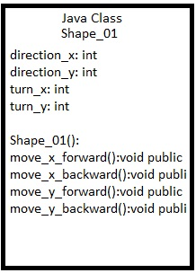
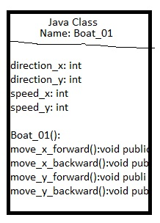
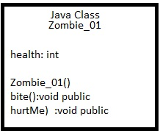
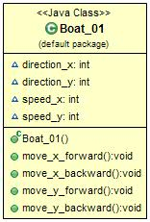
3)
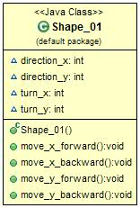
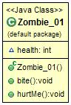

4)

5)
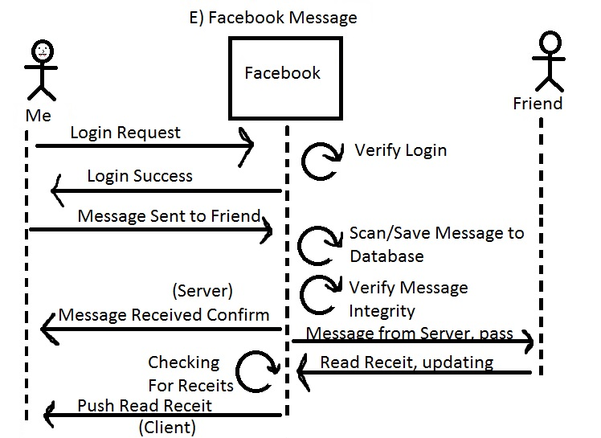
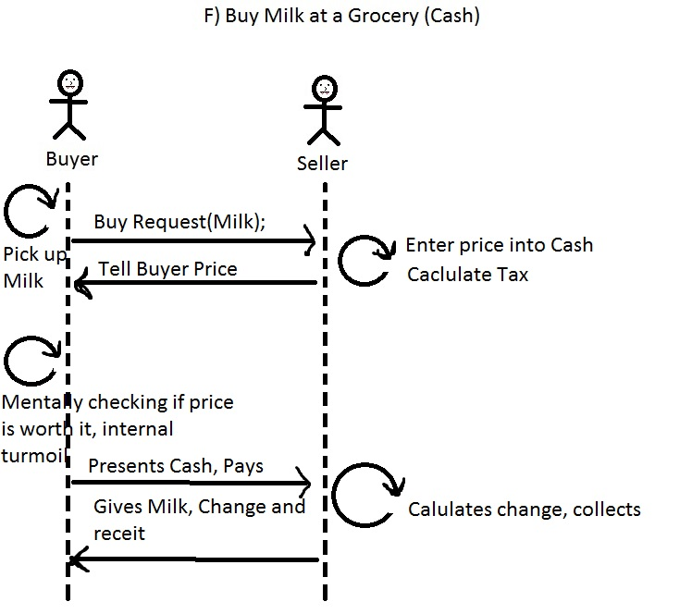
6)

